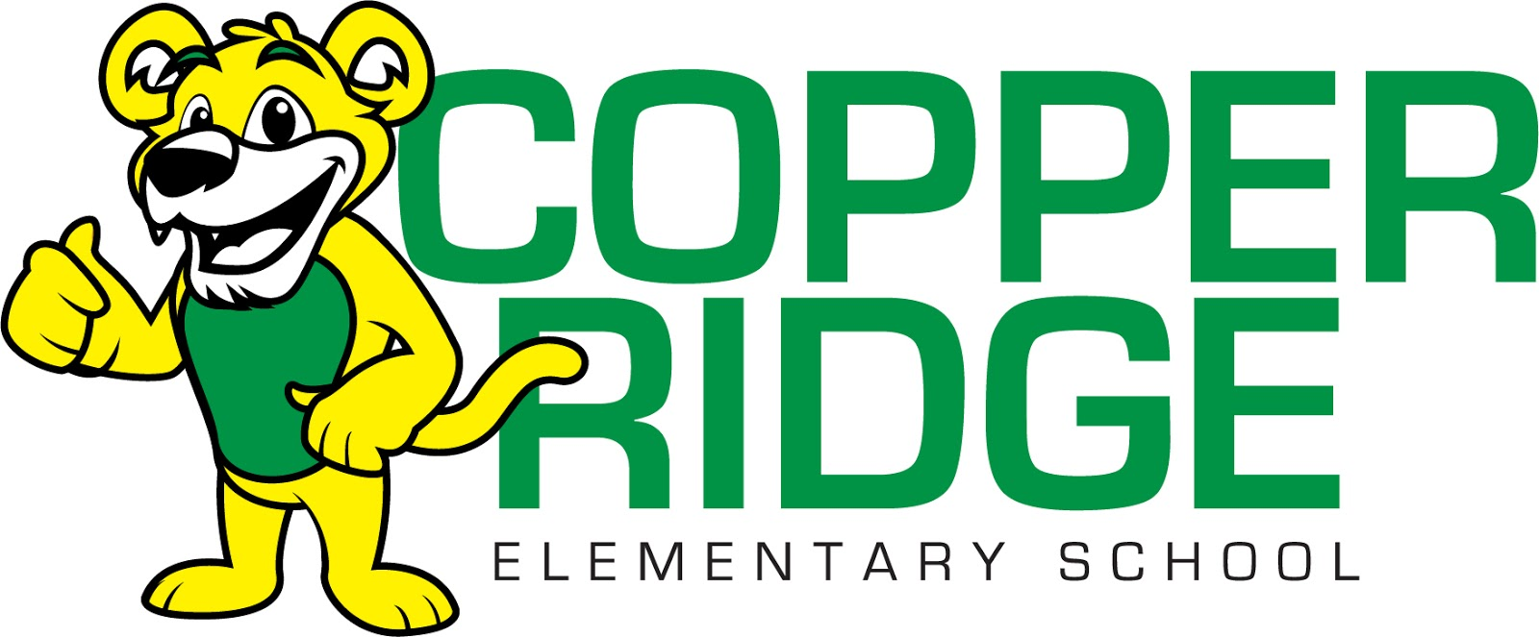

**Copper Ridge Elementary Second Grade**

**2023/2024 General Supply List**

Backpack **(non-rolling)**

Clipboard

Avery 1 inch WHITE Binder with front cover pocket

zipper pouch (2)

Ticonderoga brand pencils (24)

24 pack of Crayola crayons (2)

glue sticks (2)

scissors

Kleenex (3)

Headphones (no earbuds please)

Pink Pearl eraser (2)

Water bottle with push/flip sports lid

Clorox wipes (2)

Baby Wipes (1)

Flashcards (addition and subtraction)

**Wish List**

Band-aids

Paper towels